|  |  |
| --- | --- |
| Payload analysis@Eaton |  |
| QXtend |

1/16/2017

Regoti, Sujata

@Eaton

QXtend

1. From payload get end point

<qcom:propertyName>**EndpointURI**</qcom:propertyName>

<qcom:propertyValue> **http://ascqa.tcc.etn.com:8081/asc1qxi163/services/QdocWebService**</qcom:propertyValue>

In the above endpoint URI, asc1qxi163represents nha QXtend Inbound. For outbound : asc1qxo163

Use Link : http://ascqa.tcc.etn.com:8081/asc1qxi163

1. Get wsaTo Property

<ns2:propertyName>wsaTo</ns2:propertyName>

<ns2:propertyValue> **urn:services-qad-com:QXIasc1mfg**</ns2:propertyValue>

Here outbound receiver **QXIasc1mfg**.

1. Open above URI. Go to Configuration->Receivers->Outbound

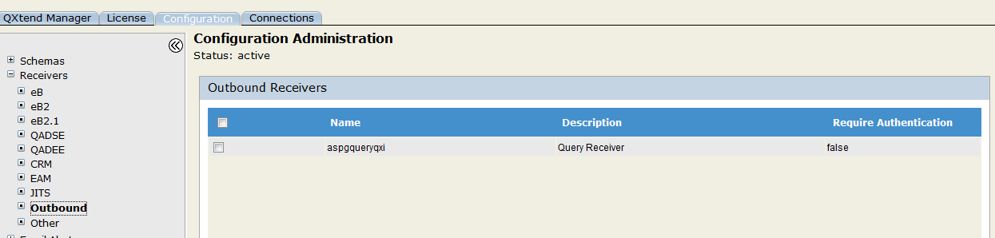

Under receivers find above receiver name.

**QXIasc1mfg not found. So payload contains warning as result.**

1. Warning as

<ns1:result>warning</ns1:result>……….

Regoti, Sujata

WCE, Sangli Intern@Eaton

@Eaton